Programming Assignment 1: Benchmark Translator - Report

李品賢, 108501023, EE4B

1. **How to compile and execute your program; (You can use screenshot to explain)**

* **main function**

In the main function (Fig. 1), I use argc and argv as input arguments on the command line. Then, I create the object myFile to read and write files, and I also create the object BT from the class Benchmark_translator to use the read_flie() & print_result(). I will explain later.

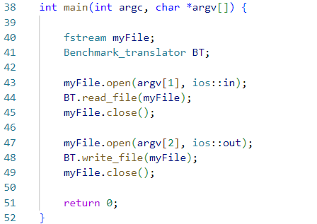

Fig. 1

* **class Benchmark_translator**

In the class Benchmark_translator (Fig. 2), here are 2 functions within the public access modifier to interact with the user (main function) so the user can read and write files. Also, here are 7 functions within the private access modifier with different functions. I will explain the detail later.

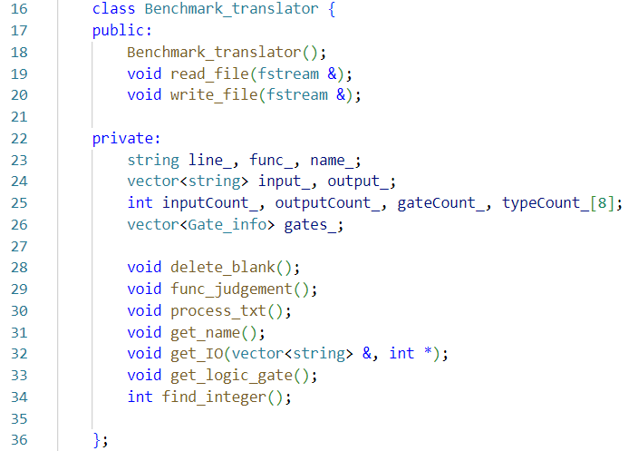

Fig. 2

* **Variables brief explanation:**

1. string line_

store the received input file by object myFile and getline function

1. string func_

store the current state (module, input, output, and, nor…)

1. string name_

store the file name (c17, c432, c880…)

1. vector<string> input_

store all the input ports

1. vector<string> output_

store all the output ports

1. int inputCount

store the input port count

1. int outputCount

store the output port count

1. int gateCount

store the overall logic gate count

1. int typeCount[8]

store the different logic gate count (and, or, nand…)

1. vector<Gate_info> gates_ (Fig. 3)

store the information of gate including ports, port count and type of it

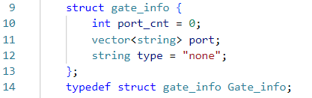

Fig. 3

* **Functions brief explanation:**

1. read_file()

to read the file (.v) line by line, and also call other functions to process the txt.

1. write_file()

write the file (.bench) with the fixed format.

1. delete_blank()

delete all blanks within the received line string.

1. func_judgement()
2. function like a finite state machine.
3. change state when receive the key word (module, input, and, nor…).
4. process_txt()
5. process the text depending on the current state.
6. If the current state is “module”, program will call get_name() to receive file name (c17, c432, c880…).
7. If the current state is “input”/“output”, program will call get_IO() to deal with the special format of I/O port.
8. If the current state is concerned with logic gate, program will call get_port(), and also the corresponding typeCount[] will increase.
9. get_ name ()

capture the text between “module” and “(”, which is file name.

1. get_IO() (Fig. 4)
2. If there exists “;” in string line_, replace the “;” with “,” in order to make the following string processing more easily.
3. If “,” still be found on the string line_, the while loop will keep processing, which means the here are remaining ports not recorded and need to be dealt with.
4. capture the text between ‘index’ storing the index of first integer in the string line_ and “,”, which is file name.
5. also, the inputCount / outputCount will increase by 1

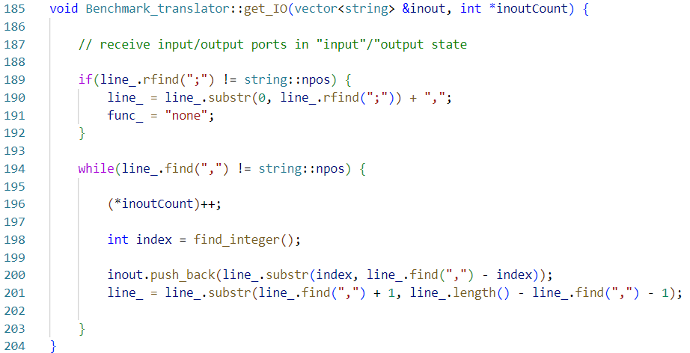

Fig. 4

1. get_logic_gate() (Fig. 5)
2. add “,” in the end of string line_in order to make the following string processing more easily.
3. This function is similar to get_IO(), but there are slight difference about the data structure in between.

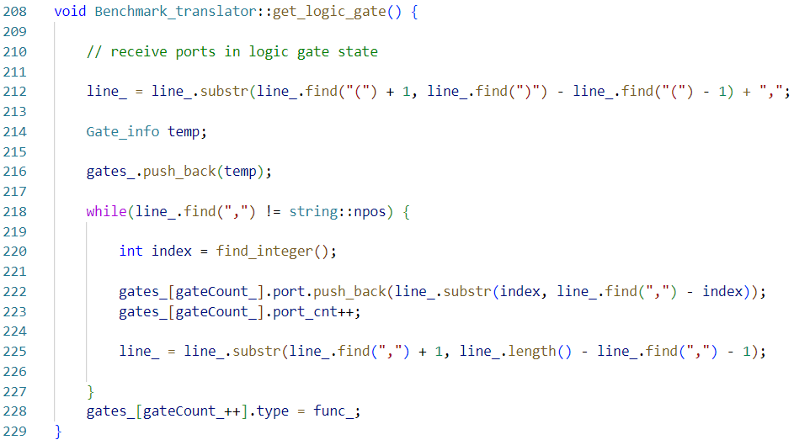

Fig. 5

1. find_integer()

started from left, search each character in string line_ and return the index of first integer.

1. **The completion of the assignment; (If you complete all requirements, just specify all)**

According to the result by ABC below, I have done all the tasks. c17.bench, c432.bench and c880.bench are all equivalent with answers.

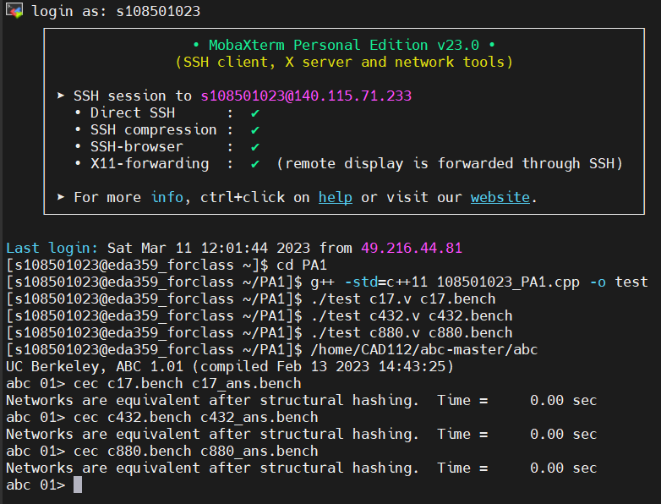

Fig. 6

1. **The hardness of this assignment and how you overcome it;**

Because I have taken the Data Structure course, I am familiar with C++ recently. But here are still some skills I didn’t get used to them, such as the implement of class and vector. Fortunately, I picked up those skills after watching the online course of C++ programing produced by prof. Chen.

There were more tasks poping up in 2022/03/10, since I found big problem when I slight edited my code. I found that I used getline() in the IDE vs, the complier would not consider “\n” (ASCII 13) a character in string, while everything changed when I compiled in workstation… The compiler viewed “\n” as a character, so the error happened in my program when using .length(). There is one more character than I thought before. I spent 4 hours debugging just for this scenario. OuQ…

1. Any suggestions about this programming assignment?

I think this project is a great material to practice C++ language. Like I said above, I picked up some missing skills and implemented it successfully. I am grateful for having this assignment.